HOLIDAY PACKAGE TERM ONE 2024
BABY CLASS

GENERAL INSTRUCTIONS:
1. This Holiday package is composed of all learning areas.
2. Each subject contains covered topics in term one.
3. Parents can assist their children in reading.
4. Parents should ensure that children attempt all questions.
5. Diagrams must be drawn in pencils.
6. Parents should ensure that the Holiday package comes back when it’s clean.
7. Good handwriting will earn you an extra mark.
8. Parents should guide the pupils and not to write for them.
9. Holiday package shall be submitted in on the first day of Term II, 2024. Any work which will come after the first day shall not be received.
10. Holiday package will be counted in the continuous assessment.
11. Parents/children who meet any challenges should contact the school for assistance.

NAME _______________________________________________
CLASS _______________________________________________

NUMBERS
1. Match the same and draw.

3. Tick the given number.
4 4 3 6
1 0 2 3

6 5 7 9
6 8 2 7

3. X the correct number
2 3 4 5

4. Trace us well.


5. Count and match.
4

3
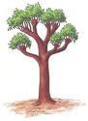
1

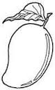
2

6. Match the same number
5 10
6 9
7 8
8 7
9 6
10 5
HEALTH HABITS
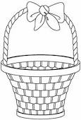
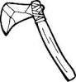
1. Match the same pictures.

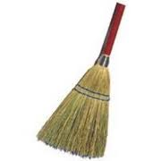

2. X the odd man out.

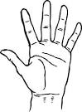
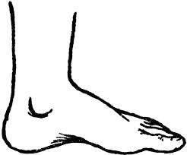
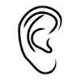


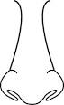

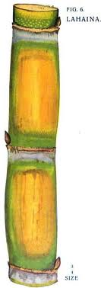
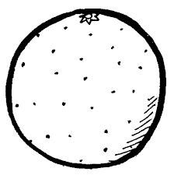
3. Tell the pictures.
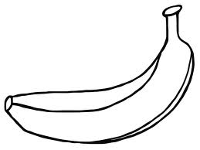
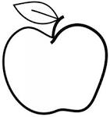
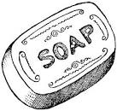

4. Circle the same.

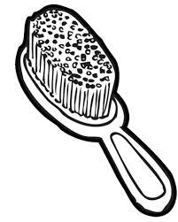

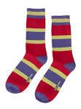


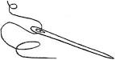

5. Match.

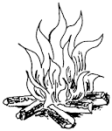
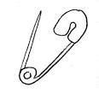

ENGLISH
1. Copy and write.
a b d c l

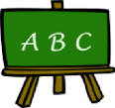
2. Match the same.

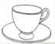


3. Tick the given picture.
 | 
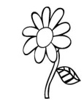 | 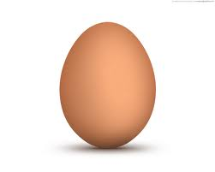
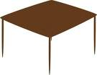 | 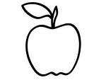  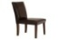
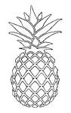
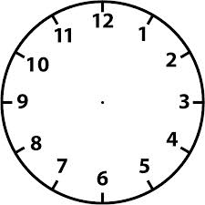

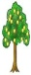
4. Join the dots.

5. Put the missing parts.
a b c

6. Read the given letters.
a b d e f
7. Copy and draw.
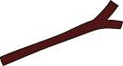

8. Match the friends.
f h
g d
h k
d f
k g
9. Name orally.

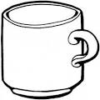
10. Z the odd man out.


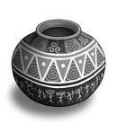


INTELLIGENCE
1. Put me right.

2. X only kites.
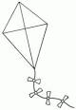



3. Join the dots.

4. Match correctly.




5. Tick the same.
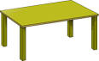



6. Draw a zig-zag.

7. Shade me well.

8. X the given picture.


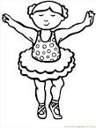

READING
1. Sound and do the action.
a t c f m d
2. Blend and read syllables.
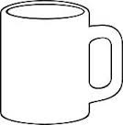
s – a = s a
t – a = t a
m – a = m a
p – a = p a

3. Circle the given sound
t p t
s s a
g h g
i i c

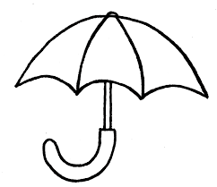

4. Match pictures of the same sounds.

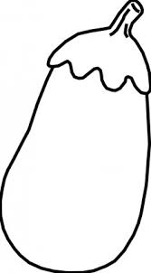

5. Match and copy.
s n ___n_____
a i __________
t c __________
c s __________
i a __________
n t __________

ART
Shade well
